Terna Engineering College
Computer Engineering Department

Class: TE Sem.: VI

Course: System Security Lab

PART A
(PART A : TO BE REFFERED BY STUDENTS)
Experiment No.03
A.1 Aim:
Implementation of Diffie Hellman Key exchange algorithm.
A.2 Prerequisite:
- Understanding of modular arithmetic.
- Basic knowledge of Asymmetric Key Cryptography and secure communication.

A.3 Outcome:
After the successful completion of this experiment, students will be able to:
- Analyze the Diffie-Hellman key exchange process and its role in secure communications.
- Implement secure key generation and exchange between two parties.

A.4 Theory:
- Diffie-Hellman Key Exchange Algorithm
- The Diffie-Hellman Key Exchange (DHKE) algorithm, proposed by Whitfield Diffie and Martin Hellman in 1976, is a method of securely exchanging cryptographic keys over an insecure communication channel. It enables two parties to jointly establish a shared secret key, which can be used for encrypting and decrypting messages.
- Working Principle:
The security of the Diffie-Hellman algorithm relies on the difficulty of solving the discrete logarithm problem, which makes it computationally infeasible for an attacker to determine the shared secret key without the private keys of the communicating parties.

Applications of Diffie-Hellman Key Exchange:
- Secure Communication Protocols:
  - Used in protocols like HTTPS, TLS/SSL, and VPNs to establish encrypted sessions.
- Key Agreement for Symmetric Cryptography:
  - Enables secure distribution of symmetric keys for encryption algorithms like AES or DES.
- Digital Signature Schemes:
  - Often used with RSA or ECC for secure authentication and integrity verification.
- Blockchain and Cryptocurrencies:
  - Ensures secure key exchanges in decentralized networks.
- Internet of Things (IoT):
  - Facilitates secure communication between connected devices.
Limitations of Diffie-Hellman Algorithm:
- Man-in-the-Middle Attack (MITM):
  - Without authentication mechanisms, an attacker can impersonate one of the parties and intercept the key exchange.
  - Solution: Use digital certificates or pre-shared keys for verification.
- Computational Overhead:
  - The algorithm can be computationally intensive for devices with low processing power.
- No Authentication:
  - It does not authenticate the parties involved in the exchange.

- ALGORITHM:
- Both parties agree on a large prime number p and a primitive root g modulo p.
- Each party selects a private key:
  - Alice selects a private key a.
  - Bob selects a private key b.
- Each party computes their public key:
  - Alice computes A=gamod pA = g^a \mod pA=gamodp.
  - Bob computes B=gbmod pB = g^b \mod pB=gbmodp.
- The public keys AAA and BBB are exchanged between Alice and Bob over an insecure channel.
- Both parties compute the shared secret key:
  - Alice computes S=Bamod pS = B^a \mod pS=Bamodp.
  - Bob computes S=Abmod pS = A^b \mod pS=Abmodp.
Since S=gabmod pS = g^{ab} \mod pS=gabmodp, both computations yield the same shared secret key.
EXAMPLE:
- Agree on p=23p = 23p=23 (prime number) and g=5g = 5g=5 (primitive root modulo 23).
- Alice chooses a=6a = 6a=6 (private key).
  - Computes A=56mod 23=8A = 5^6 \mod 23 = 8A=56mod23=8.
- Bob chooses b=15b = 15b=15 (private key).
  - Computes B=515mod 23=19B = 5^{15} \mod 23 = 19B=515mod23=19.
- Exchange public keys A=8A = 8A=8 and B=19B = 19B=19.
- Compute the shared secret key:
  - Alice: S=Bamod p=196mod 23=2S = B^a \mod p = 19^6 \mod 23 = 2S=Bamodp=196mod23=2.
  - Bob: S=Abmod p=815mod 23=2S = A^b \mod p = 8^{15} \mod 23 = 2S=Abmodp=815mod23=2.
- The shared secret key is S=2S = 2S=2.
Code:
#include<stdio.h>
long long int power(int a,int b,int mod)
{
long long int t;
if(b==1)
return a;
t=power(a,b/2,mod);
if(b%2==0)
return (t*t)%mod;
else
return (((t*t)%mod)*a)%mod;
}
long long int calculateKey(int a,int x,int n)
{
return power(a,x,n);
}
int main()
{
int n,g,x,a,y,b;
printf("Enter the value of n and g : ");
scanf("%d%d",&n,&g);
printf("Enter the value of x for the first person : ");
scanf("%d",&x);
a=power(g,x,n);
printf("Enter the value of y for the second person : ");
scanf("%d",&y);
b=power(g,y,n);
printf("key for the first person is : %lld\n",power(b,x,n));
printf("key for the second person is : %lld\n",power(a,y,n));
return 0;
}

Output:
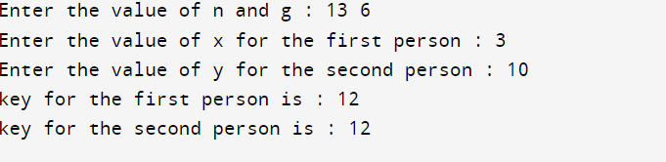

PART B
(PART B : TO BE COMPLETED BY STUDENTS)
(Students must submit the soft copy as per following segments within two hours of the practical. The soft copy must be uploaded on the Blackboard or emailed to the concerned lab in charge faculties at the end of the practical in case the there is no Black board access available)

Roll No.: C-54 | Name: Quazi Md Moinuddin
Class : TE Comps C | Batch : C-3
Date of Experiment: 06.02.25 | Date of Submission:11.02.25
Grade :

B.1 | Output of Diffie-Hellman Key Exchange Algorithm:
(Add snapshot of output of Diffie-Hellman Key Exchange Algorithm)
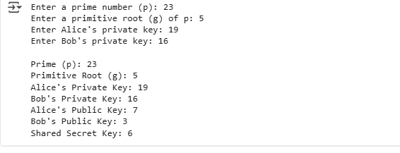
B.2. | Source Code of Diffie- Hellman Key Exchange Algorithm:  import random  # Step 1: Take input for prime number (p) and primitive root (g)  p = int(input("Enter a prime number (p): ")) # Prime number  g = int(input("Enter a primitive root (g) of p: ")) # Primitive root of p  # Step 2: Alice and Bob choose their private keys  private_key_A = int(input("Enter Alice's private key: ")) # Alice's private key  private_key_B = int(input("Enter Bob's private key: ")) # Bob's private key  # Step 3: Compute public keys  public_key_A = (g ** private_key_A) % p # Alice's public key  public_key_B = (g ** private_key_B) % p # Bob's public key  # Step 4: Exchange public keys and compute the shared secret  shared_secret_A = (public_key_B ** private_key_A) % p # Computed by Alice  shared_secret_B = (public_key_A ** private_key_B) % p # Computed by Bob  # Step 5: Verify that both shared secrets are the same  assert shared_secret_A == shared_secret_B  # Display the results  print(f"\nPrime (p): {p}")  print(f"Primitive Root (g): {g}")  print(f"Alice's Private Key: {private_key_A}")  print(f"Bob's Private Key: {private_key_B}")  print(f"Alice's Public Key: {public_key_A}")  print(f"Bob's Public Key: {public_key_B}")  print(f"Shared Secret Key: {shared_secret_A}") # Both should have the same key
B.3 | Question of Curiosity:  - What is the Diffie-Hellman Key Exchange Algorithm?  - Differentiate between symmetric and asymmetric key exchange algorithms.  - Explain the use of the Diffie-Hellman Key Exchange Algorithm.  - List and explain different possible attacks on Diffie-Hellman.  - Explain the concept of Perfect Forward Secrecy (PFS) in Diffie-Hellman.Perfect Forward Secrecy (PFS) ensures that even if a private key is compromised in the future, previous session keys cannot be decrypted.  - How does the Diffie-Hellman algorithm ensure secure key exchange without sharing the private key?    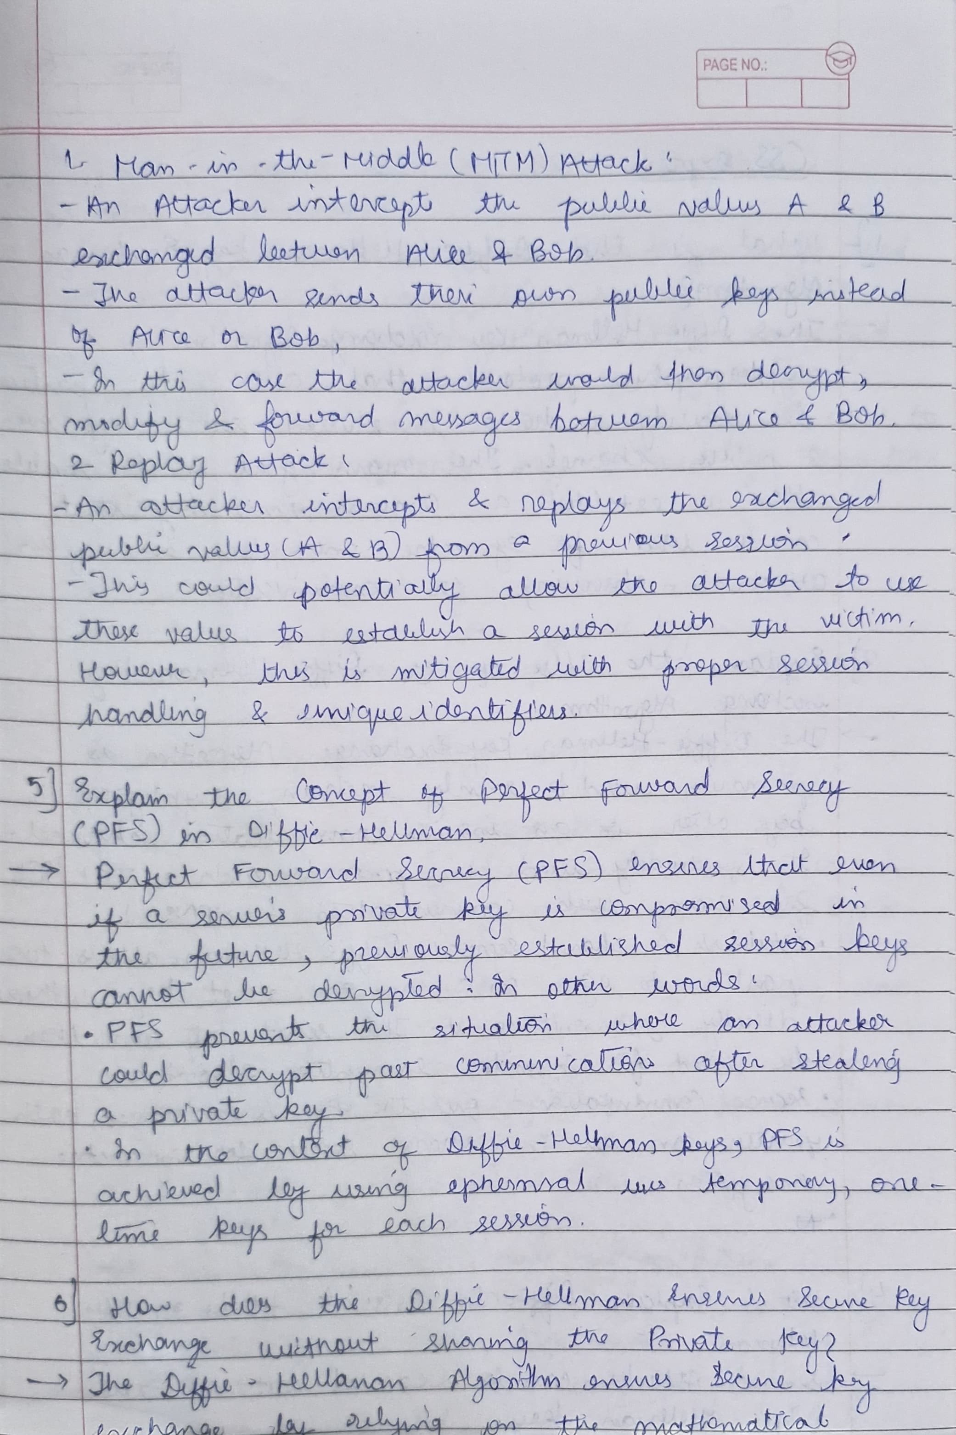
 | 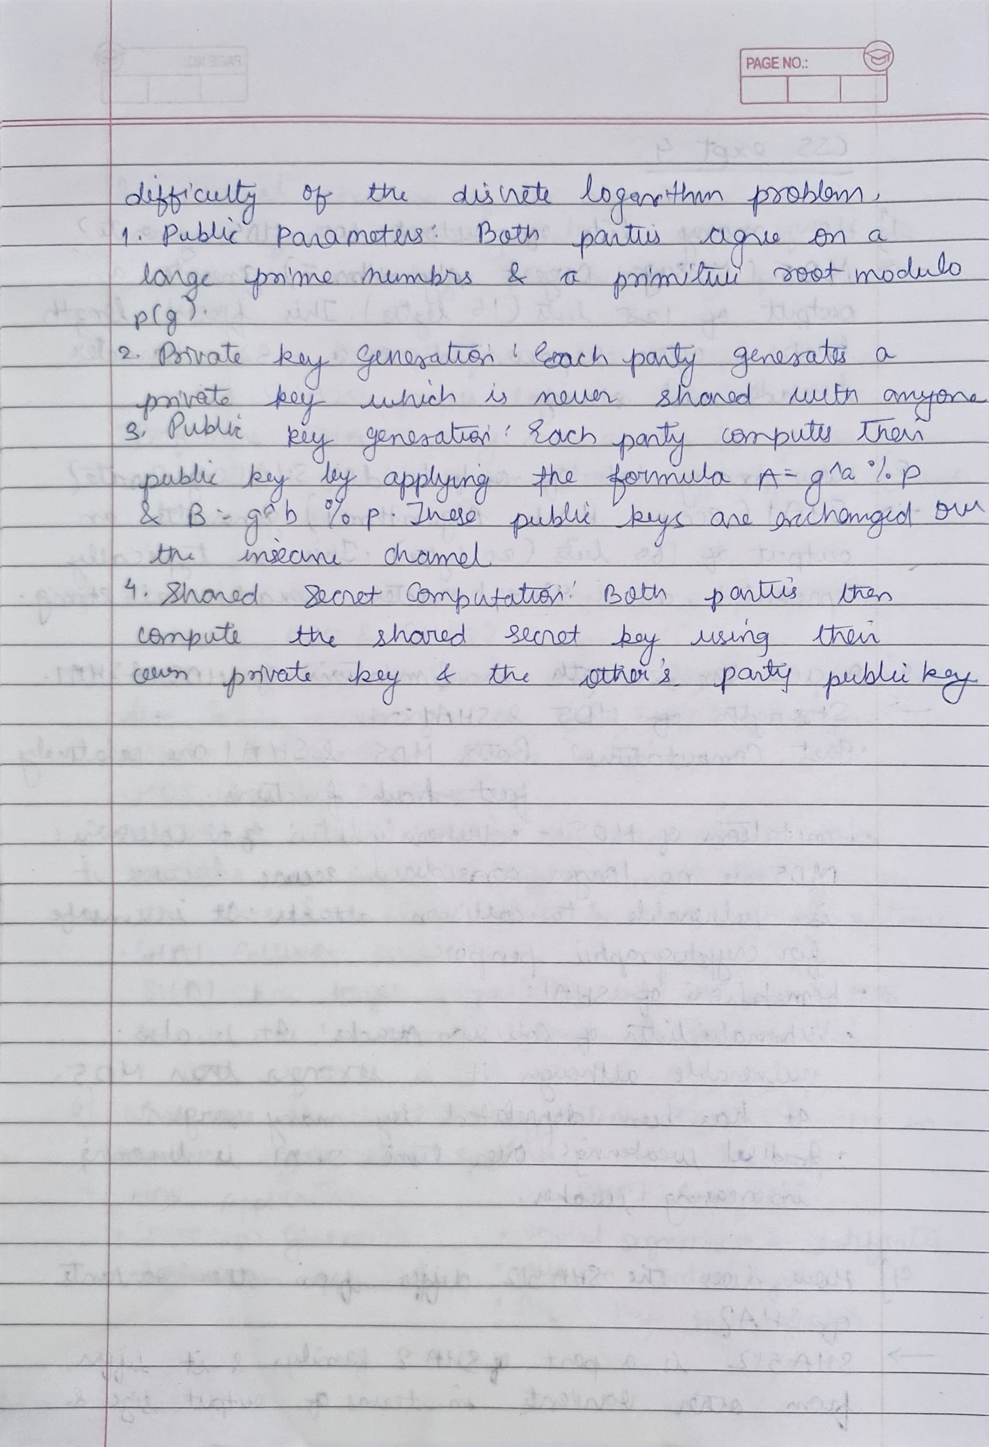
B.4 | Conclusion:  The Diffie-Hellman Key Exchange is a foundational cryptographic algorithm that allows two parties to securely generate a shared secret key over an insecure communication channel. It ensures that:  1. Secure Key Exchange – The shared key is never transmitted directly, making it resistant to eavesdropping.  2. Mathematical Security – The security relies on the difficulty of the Discrete Logarithm Problem, making it computationally hard for attackers to derive the private keys.  3. Foundation for Modern Cryptography – It is widely used in TLS, VPNs, SSH, and other secure communication protocols.  4. Vulnerabilities & Mitigation – It is vulnerable to Man-in-the-Middle (MITM) attacks, which can be mitigated using authentication mechanisms like digital signatures.

